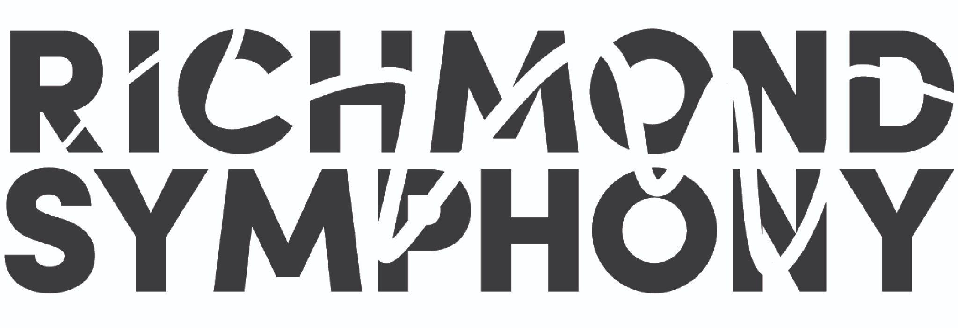
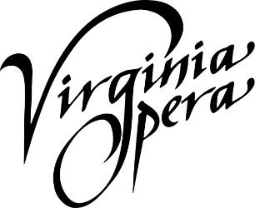
Release: February 8, 2023
Virginia Opera and Richmond Symphony Receive
Special Recognition Award from Virginia Commission for the Arts

Grant directly benefits world premiere production of Loving v. Virginia co-produced by
Virginia Opera and Richmond Symphony

Hampton Roads, Richmond and Fairfax, VA (February 8, 2023)— The Virginia Commission for the Arts announced a special recognition grant of $15,000 for three consecutive years, totaling $45,000 in support of the newly-commissioned opera of Loving v. Virginia. Peggy Kriha Dye General Director & CEO of Virginia Opera, and Lacey Huszcza, Executive Director of the Richmond Symphony, jointly received the award at a special ceremony held at the Virginia Museum of Fine Arts on January 23, 2023.

“The Virginia Commission for the Arts is thrilled to invest in this story of, by, and for Virginians. Through the Loving v. Virginia opera, the Virginia Opera and Richmond Symphony are innovating in the arts while bringing an important part of our history to a broad audience. The VCA is excited for the opera’s debut and honored to be part of its development.” – Margaret Hancock, Executive Director, Virginia Commission for the Arts
The award will support the commission of Loving v. Virginia - an operatic retelling of the groundbreaking United States Supreme Court case centered around the interracial marriage of Mildred and Richard Loving. Composer Damien Geter and librettist Jessica Murphy Moo have been commissioned by the two leading organizations to create the opera which will be premiered in venues across Virginia in 2025.
Peggy Kriha Dye, General Director and CEO of Virginia Opera: “Joining forces with our longstanding partner the Richmond Symphony will expand the operatic repertoire to include one of the most important stories of racial justice in American history. To be recognized by the Virginia Commission for the Arts for this project is a testament to the importance of this story, and to the artistic quality of both our organizations.”

Richmond Symphony’s Executive Director, Lacey Huszcza: “Loving v. Virginia promises to impact our communities in very positive ways. Over the course of the development of this new work we will have the opportunity to engage the public with this important Virginian story. In the end, we hope everyone will join us on this journey, and are grateful for the support and recognition of this project from the Virginia Commission for the Arts.”

Loving v. Virginia – Production Information

Damien Geter (Composer) infuses classical music with various styles from the black diaspora to create music that furthers the cause for social justice. Damien’s growing body of work includes chamber, vocal, and orchestral works. Recent commissions include Cantata for a Hopeful Tomorrow for The Washington Chorus, Invisible for Opera Theater Oregon, The Justice Symphony for the University of Michigan, and String Quartet No. 1, Neo-Soul for All Classical Portland and On-Site Opera. His large work, An African American Requiem, will premiere in Spring 2022 in partnership with Resonance Ensemble and the Oregon Symphony. The book he co-authored, Music in Context: An Examination of Western European Music Through a Sociopolitical Lens, is available on Amazon or directly from the publisher, Kendall Hunt. Damien currently serves as the Artistic Advisor for Resonance Ensemble and Portland Opera. He is the owner of DG Music, Sans Fear Publishing.

Jessica Murphy Moo (Librettist) wrote the librettos for Lyric Opera of Chicago’s 2019/2020 opera for young audiences, Earth to Kenzie, a co-commission between Lyric Opera of Chicago and Seattle Opera, and An American Dream, a commission by Seattle Opera. Jessica is editor of Portland magazine, the award-winning publication of the University of Portland. She is a former senior communications manager for Seattle Opera and an adjunct instructor teaching nonfiction writing for the University of Washington’s Professional and Continuing Education division. Jessica was a 2016 fellow at Tapestry Opera’s Librettist Composer Laboratory Workshop. She has held teaching positions at Emerson College, Harvard University, Boston University, Seattle Pacific University, University of Washington, and Seattle Opera.

About the Virginia Commission for the Arts
Established in 1968, the VCA is the state agency dedicated to investing in the arts of Virginia. Through allocations made possible by the National Endowment for the Arts and the General Assembly, the VCA utilizes investments to empower arts leaders, arts educators, and arts practitioners. In doing so, we create a virtuous cycle of those who not just participate in and appreciate the arts, as stated in our enabling legislation, but those who serve as change agents and advance the Commonwealth of Virginia.

About Virginia Opera
Virginia Opera, the official opera company of the Commonwealth of Virginia, is one of the finest regional opera companies in the nation and is the only company to perform regularly in three separate main stage venues: the Harrison Opera House in Norfolk, the Carpenter Theatre at the Dominion Energy Center in Richmond, and Center for the Arts at George Mason University in Fairfax. Organized in 1974, Virginia Opera is respected nationwide for the identification and presentation of the finest young artists, for the musical and dramatic integrity of its productions, and for the ingenuity and variety of its education and outreach programs.

About Richmond Symphony
The Richmond Symphony is dedicated to putting music at the center of its community, creating joy, connection, expression, and collaborations. Each season, the Richmond Symphony offers more than 200 public performances for approximately 250,000 patrons through concerts and educational programs and collaborates with other organizations, such as Morgan Avery McCoy, Inc., for special projects. The Symphony maintains an active touring schedule that brings live symphonic performances to rural communities. Founded in 1957, the Symphony includes 70 professional Orchestra Musicians and a 150-voice volunteer Chorus. Demonstrating a dedication to music education, the Richmond Symphony School of Music (RSSoM) was founded in 2020 and includes a 120 strong Youth Orchestra Program of all skill levels as well as online enrichment and instruction for both school-aged and adult learners.

CONTACT
Amanda J. Ivy
Director of Marketing
Virginia Opera
amanda.ivy@vaopera.org
757-627-9545 ext. 3322

Sara Hunt
Public Relations - Richmond Symphony
sarahuntpr@gmail.com
804-994-1120

