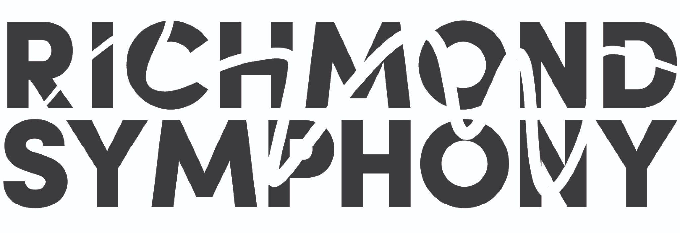
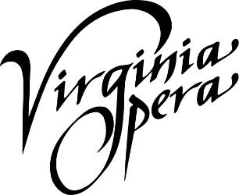
FOR IMMEDIATE RELEASE
Virginia Opera and Richmond Symphony Announce
Denyce Graves secured to direct World Premiere Co-Commission of Loving v. Virginia

Announcement of world-renowned mezzo-soprano joining project coincides with summer piano-vocal workshop and public reading

Hampton Roads and Richmond, VA (July 26, 2023) - Virginia Opera and Richmond Symphony are thrilled to announce world-renowned mezzo-soprano Denyce Graves is joining the creative team of Loving v. Virginia as Stage Director. Graves, a legitimate superstar in the opera world as a singer performing on the world’s most impressive stages, recently expanded her talents to include stage-directing, with recent credits at companies including Minnesota Opera, Glimmerglass Festival, and Portland Opera. Graves will join Composer Damien Geter and Librettist Jessica Murphy Moo in the early stages of developing this new work, along with an entirely new production, scheduled to make its world premiere in April 2025. Loving v. Virginia is being co-commissioned by Virginia Opera and the Richmond Symphony.
Adam Turner, Artistic Director of Virginia Opera: “The artistic integrity of our world premiere of Loving v. Virginia is paramount. Enlisting Denyce’s vision and leadership adds a critical voice to the Creative Team, augmenting Damien and Jessica’s talents, and allowing preparation for the 2025 premiere production to take form in earnest.”
Denyce Graves, Director: “It is an honor to be asked to join a team that is developing a project around one of the most important moments of Social Justice in the history of our country. I am confident Damien and Jessica will deliver a score and libretto worthy of the Lovings, and am eager to manifest their blueprint into a world-class production.”
Loving v. Virginia will be an operatic retelling of the groundbreaking United States Supreme Court case centered around the interracial marriage of Mildred and Richard Loving. In 1958, they were sentenced to prison for marrying each other, which was illegal in Virginia due to its Racial Integrity Act of 1924. Having appealed their conviction to the Supreme Court of Virginia, which upheld the conviction, the United States Supreme Court issued a unanimous decision overturning their conviction in 1967. Seen as a significant victory for civil rights in the United States, Loving v. Virginia was cited as a precedent in the 2015 decision Obergefell v. Hodges, which legalized same-sex marriage.
A series of workshops are part of the process of creating this new work of art, including the libretto workshop and public reading which took place in November 2022. In partnership with the Institute for Contemporary Art at VCU, the next workshop will feature the piano-vocal score of the first act of the opera. These work sessions will include principal singers, with chorus and pianist, allowing the Creative Team to further develop the score. In conjunction with this workshop will be two opportunities for the public to participate: August 19, 2023 at 5:30pm at the ICA at VCU in Richmond, and August 20, 2023 at 2:30 pm at the Harrison Opera House in Norfolk. The programs are free and open to the public. Reservations are requested at vaopera.org/events. Press passes are available by contacting Virginia Opera’s Director of Marketing, Amanda Ivy, at Amanda.ivy@vaopera.org.
Peggy Kriha Miller, General Director and CEO of Virginia Opera: “It is such a rare opportunity to see art being created. We are so excited to be able to welcome the community to witness this process, and get a sneak peek to the music that will be premiering in Virginia. This project is truly home-grown – which is important to tell a uniquely Virginian story.”
Richmond Symphony’s Executive Director, Lacey Huszcza: “It is so exciting that we are mere weeks away from hearing the first notes of Loving v. Virginia. At each step this project has brought together some of the greatest talent available including Damien, Jessica, and now Denyce. The Richmond Symphony could not be happier to be co-commissioning this work.”
Major support for the commissioning and production of this work comes from Altria. Additional funding has been provided by OPERA America’s 2022 Repertoire Development Grant, as well as a special recognition award from the Virginia Commission for the Arts, which receives support from the Virginia General Assembly and the National Endowment for the Arts, a federal agency. Individuals interested in supporting the work can join the “Commissioning Club.” Donors will receive special access to the workshops, the creative team, the cast, and other membership benefits.

Loving v. Virginia – Production Information:
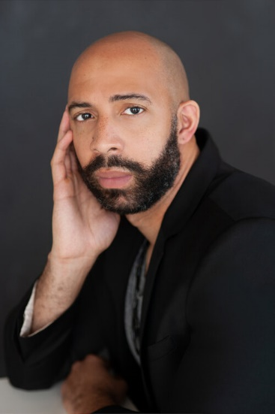
Damien Geter (Composer) infuses classical music with various styles from the black diaspora to create music that furthers the cause for social justice. He is Composer-in-Residence at the Richmond Symphony through the 2024-25 season, and serves as Interim Music Director and Artistic Advisor at Portland Opera, as well as the Artistic Advisor for Resonance Ensemble. Geter’s rapidly growing body of work includes chamber, vocal, orchestral, and full operatic works, with his compositions being praised for their “Skillful vocal writing” (Wall Street Journal). In the 2023-2024 season, Des Moines Metro Opera presents the full-length world premiere of his opera, American Apollo. Last season, COTTON was given its world premiere in Philadelphia followed by its Washington, D.C. premiere at The Kennedy Center, presented by Washington Performing Arts, and his motet was performed by Emmanuel Music. He also conducted his own piece, An African American Requiem, at Fort Worth Opera, plus led the performance of ABSENCE: Terence Blanchard with Portland Opera. Future commissions include premieres at Seattle Opera and Emmanuel Music, and world premiere operatic productions in 2024, 2025, and 2026 at the Seattle, Virginia, InSeries, and Portland Operas. Geter will also have subsequent premieres at Richmond Symphony.

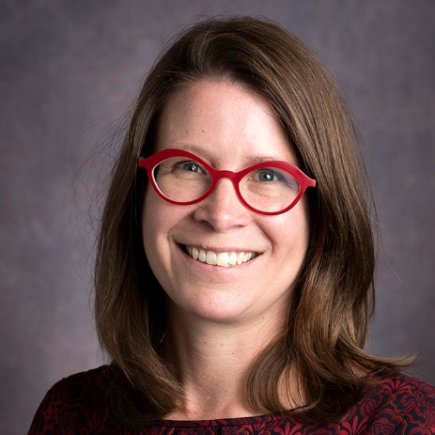
Jessica Murphy Moo (Librettist) wrote the librettos for Lyric Opera of Chicago’s 2019/2020 opera for young audiences, Earth to Kenzie, a co-commission between Lyric Opera of Chicago and Seattle Opera, and An American Dream, a commission by Seattle Opera. Jessica is editor of Portland magazine, the award-winning publication of the University of Portland. She is a former senior communications manager for Seattle Opera and an adjunct instructor teaching nonfiction writing for the University of Washington’s Professional and Continuing Education division. Jessica was a 2016 fellow at Tapestry Opera’s Librettist Composer Laboratory Workshop. She has held teaching positions at Emerson College, Harvard University, Boston University, Seattle Pacific University, University of Washington, and Seattle Opera.

Denyce Graves (Director) is recognized as "an operatic superstar of the 21st century" by USA Today; mezzo-soprano Denyce Graves’ career has garnered unparalleled popular and critical acclaim. Ms. Graves’ acclaimed appearances as Carmen and Dalila in Samson et Dalila have resounded in the world’s greatest opera houses. Her full opera recordings include Gran Vestale in La vestale, recorded live from La Scala with Riccardo Muti for Sony Classical; Queen Gertrude in Thomas's Hamlet for EMI Classics; Maddalena in Rigoletto with the Metropolitan Opera Orchestra under James Levine; and Emilia in Otello with Plácido Domingo and the Opéra de Paris, Bastille Orchestra under Myung-Whun Chung, both for Deutsche Grammophon. She is the Artistic Director and Founder of The Denyce Graves Foundation, which aims to promote equity and inclusion in American classical vocal arts through an unprecedented approach: championing the hidden musical figures of the past while uplifting young artists of world-class talent from all backgrounds.

About Virginia Opera
Virginia Opera, the official opera company of the Commonwealth of Virginia, is one of the finest regional opera companies in the nation and is the only company to perform regularly in three separate main stage venues: the Harrison Opera House in Norfolk, the Carpenter Theatre at the Dominion Energy Center in Richmond, and Center for the Arts at George Mason University in Fairfax. Organized in 1974, Virginia Opera is respected nationwide for the identification and presentation of the finest young artists, for the musical and dramatic integrity of its productions, and for the ingenuity and variety of its education and outreach programs.

About Richmond Symphony
The Richmond Symphony is dedicated to putting music at the center of its community, creating joy, connection, expression, and collaborations. Each season, the Richmond Symphony offers more than 200 public performances for approximately 250,000 patrons through concerts and educational programs and collaborates with other organizations, such as Morgan Avery McCoy, Inc., for special projects. The Symphony maintains an active touring schedule that brings live symphonic performances to rural communities. Founded in 1957, the Symphony includes 70 professional Orchestra Musicians and a 150-voice volunteer Chorus. Demonstrating a dedication to music education, the Richmond Symphony School of Music (RSSoM) was founded in 2020 and includes a 120 strong Youth Orchestra Program of all skill levels as well as online enrichment and instruction for both school-aged and adult learners.

About the Institute for Contemporary Art
The Institute for Contemporary Art at Virginia Commonwealth University is a non-collecting institution that showcases a fresh slate of changing exhibitions and programs. The ICA is a place to explore new ideas, providing an open forum for dialogue and collaboration across the region and the world. Mirroring the increasing emphasis on cross-disciplinary studies across VCU, the ICA has created a new environment for artists and scholars from around the world to test ideas. As a university-wide resource, the ICA links campus, community and contemporary artists by supporting local creative communities, engaging an international network of contemporary artists and organizations, and encouraging collaborations with VCU departments, faculty, students and the Richmond community. The ICA is a responsive institution that offers a broad range of artistic perspectives from across the world, with the goal of questioning assumptions and encouraging critical discourse. For more information on the ICA, please visit icavcu.org.
Sponsors:
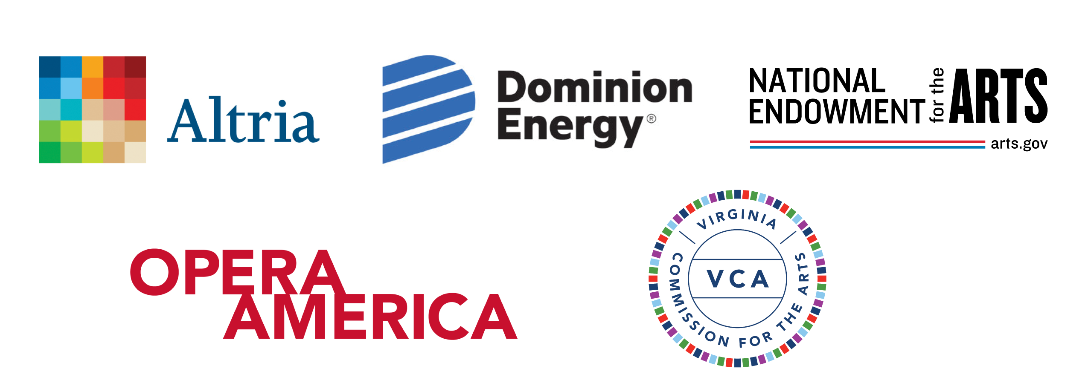
CONTACT
Amanda J. Ivy
Director of Marketing - Virginia Opera
Amanda.ivy@vaopera.org
757-627-9545 ext. 3322

Sara Hunt
Public Relations - Richmond Symphony
sarahuntpr@gmail.com

