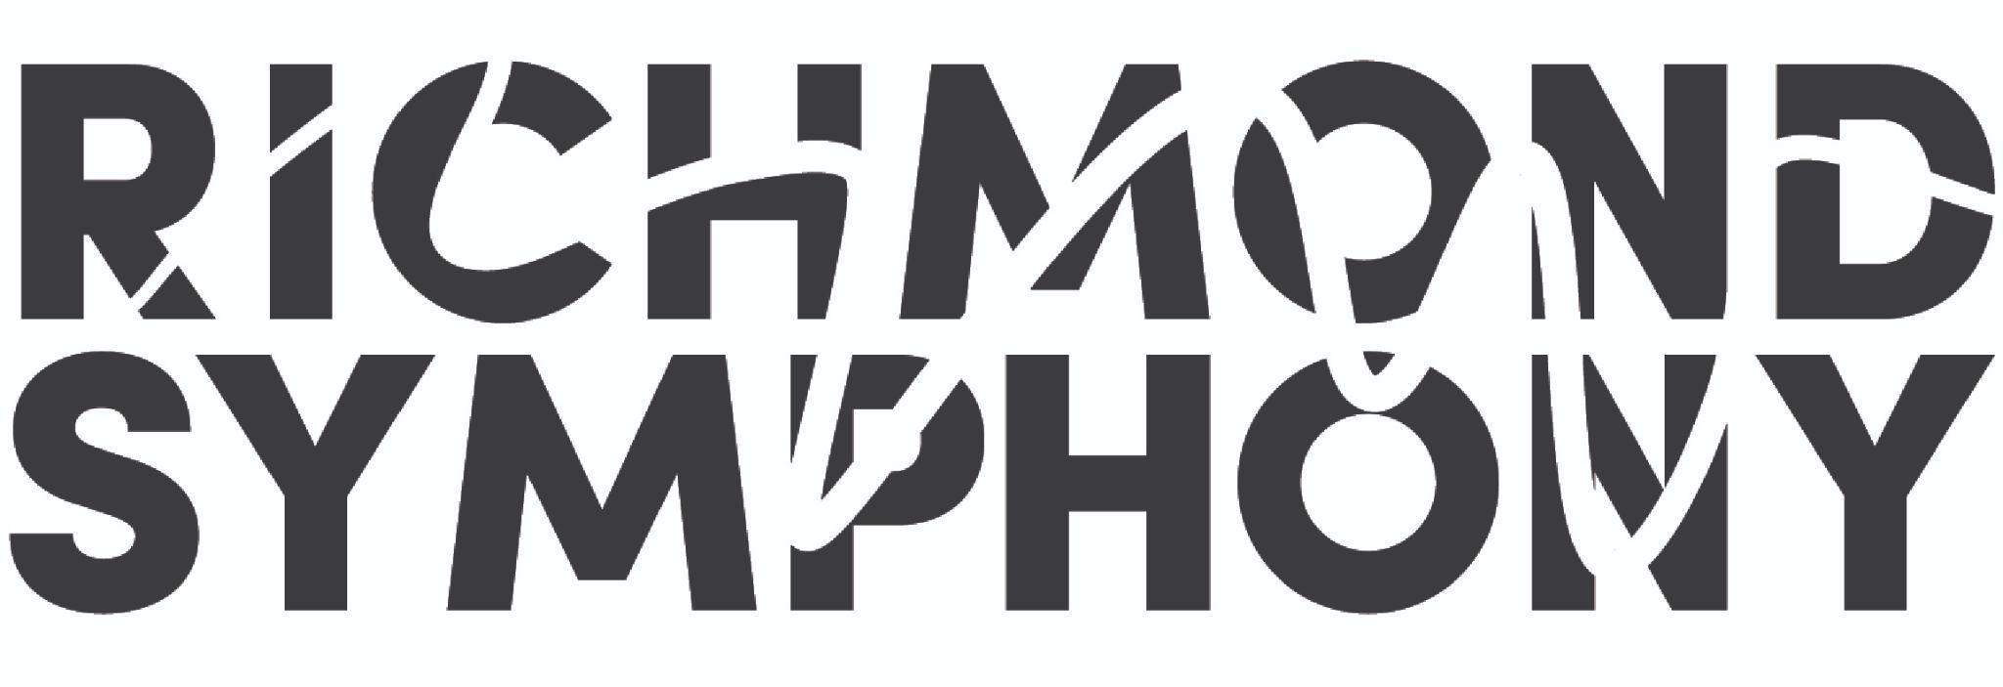

EMBARGOED | EMBARGOED |EMBARGOED
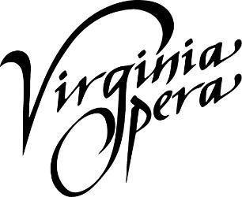
Release: May 16, 2022
Virginia Opera and Richmond Symphony Announce
Loving v. Virginia to become subject of a major new opera

Historic project will center around Loving v. Virginia to premiere as part of Virginia Opera’s 50th Anniversary Season in 2025

Hampton Roads, Richmond and Fairfax, VA (May 16, 2022)— The Virginia Opera and Richmond Symphony announce the co-commission of Loving v. Virginia - an operatic retelling of the groundbreaking United States Supreme Court case centered around the interracial marriage of Mildred and Richard Loving. Composer Damien Geter and librettist Jessica Murphy Moo have been commissioned by the two leading organizations to create the opera which will be premiered in venues across Virginia in 2025.

In 1958, the Lovings were sentenced to prison for marrying each other, which was illegal in Virginia due to its Racial Integrity Act of 1924. Having appealed their conviction to the Supreme Court of Virginia, which upheld the conviction, the United States Supreme Court issued a unanimous decision overturning their conviction in 1967. Seen as a major victory for civil rights in the United States, Loving v. Virginia was cited as precedent in the 2015 decision Obergefell v. Hodges, which legalized same-sex marriage.

Damien Geter, Composer: “As a native Virginian, the historical significance of Loving v. Virginia has remained with me since I was a teenager, but I’m finding there are many who are unfamiliar with this landmark case. Coming back home to Virginia and collaborating with Virginia Opera (the company where I first experienced opera) and working with Jessica Murphy Moo to tell the story of Mildred and Richard Loving is important not only for the sake of honoring their legacy, but also for ensuring the future of the art form.”

Jessica Murphy Moo, Librettist: “Mildred and Richard Loving made my own family possible. What an honor and responsibility it is to be part of a team telling their story. Think for a moment about what they achieved—they were only two people and yet they stood up to legalized racism and enacted lasting change. Their story is an inspiration. And it’s also an opera! The vision they were working toward—equality, home, love—these subjects are part of opera’s vast terrain. I know that composer Damien Geter’s music will make us all feel—in new ways—the weight and importance of the Lovings’ contribution to racial justice in America.”

Adam Turner, Artistic Director of Virginia Opera said: "Deciding how best to celebrate VO’s 50th Anniversary of producing opera in the Commonwealth has been the subject of countless conversations for a number of years. Early on we recognized the importance of achieving at least one of two key goals. First, to feature a Virginia story. Second, to feature a Virginia composer. With composer and Virginia-native Damien Geter, and the powerful, courageous story of Loving v. Virginia, we are thrilled to have secured both goals!”

Peggy Kriha Dye, General Director and CEO of Virginia Opera: “Loving v. Virginia opened the door for equality on so many levels for all Americans. We are humbled to be taking on the task of telling that story and are hopeful that the community will embrace the project over the next three years. We are thrilled to count the Richmond Symphony as our major partner in developing the work, and for the ICA for providing us an amazing facility to support the creation of the work.”

Richmond Symphony’s Executive Director, Lacey Huszcza: “We are honored to be co-commissioning this profound work from composer Damien Geter and librettist Jessica Murphy Moo - they are the perfect combination of talent and empathy. No one can fail to be touched by the Lovings’ story and the freedoms their struggle created for us today. Our intention is to lift this story up as an inspiration to not just opera and classical music audiences but to anyone who cares about equality and social justice. Virginia Opera and Richmond Symphony have aligned missions in championing traditionally unheard voices, advancing local artists, putting our living art forms at the center of our communities and we invite the public to follow our story and watch the opera develop over the next three years.”

The announcement is being marked by two press events in Richmond (at the Virginia Commonwealth University’s Institute of Contemporary Art) and Norfolk (at the Harrison Opera House), Virginia. Damien Geter and the executive and artistic leadership of Virginia Opera and Richmond Symphony are providing an opportunity for press and potential partners to join a Q&A session, hear live performances of Damien’s work, and sign up to a special Commissioning Club to support the opera’s development. Virginia Opera will be 50 years old in 2025, the new opera will be the perfect ending for such a celebratory season.

Initial partner in the project is the Institute of Contemporary Art at Virginia Commonwealth University. Dominic Willsdon, Executive Director of the Institute for Contemporary Art at VCU issued this statement: “We believe that by introducing more people to the creative process we can all learn deeply and intimately why the Loving story resonates for so many of us. And we can understand what it takes to create, together, a major new work of art.”

Beginning in November 2022, a series of workshops will mark progress in the commissioning process. Over the course of the next three years, workshops will be held to review the development of the libretto, vocal writing, the orchestral score, and the production design. The culmination of this work will be celebrated with the world-premiere tour at the Harrison Opera House in Norfolk, Dominion Energy Center in Richmond, and Center for the Arts at George Mason University in Fairfax.

Early support for this new work was received from OPERA America’s 2022 Repertoire Development Grant. Additional funding will come from Corporations, Foundations, and other government funding agencies. Individuals interested in supporting the work can join the “Commissioning Club.” Donors will receive special access to the workshops, the creative team, the cast, and other benefits of membership.

Loving v. Virginia – Production Information

Damien Geter (Composer) infuses classical music with various styles from the black diaspora to create music that furthers the cause for social justice. Damien’s growing body of work includes chamber, vocal, and orchestral works. Recent commissions include Cantata for a Hopeful Tomorrow for The Washington Chorus, Invisible for Opera Theater Oregon, The Justice Symphony for the University of Michigan, and String Quartet No. 1, Neo-Soul for All Classical Portland and On-Site Opera. His large work, An African American Requiem, will premiere in Spring 2022 in partnership with Resonance Ensemble and the Oregon Symphony. The book he co-authored, Music in Context: An Examination of Western European Music Through a Sociopolitical Lens, is available on Amazon or directly from the publisher, Kendall Hunt. Damien currently serves as the Artistic Advisor for Resonance Ensemble and Portland Opera. He is the owner of DG Music, Sans Fear Publishing.

Jessica Murphy Moo (Librettist) wrote the librettos for Lyric Opera of Chicago’s 2019/2020 opera for young audiences, Earth to Kenzie, a co-commission between Lyric Opera of Chicago and Seattle Opera, and An American Dream, a commission by Seattle Opera. Jessica is editor of Portland magazine, the award-winning publication of the University of Portland. She is a former senior communications manager for Seattle Opera and an adjunct instructor teaching nonfiction writing for the University of Washington’s Professional and Continuing Education division. Jessica was a 2016 fellow at Tapestry Opera’s Librettist Composer Laboratory Workshop. She has held teaching positions at Emerson College, Harvard University, Boston University, Seattle Pacific University, University of Washington, and Seattle Opera.

About Virginia Opera
Virginia Opera, the official opera company of the Commonwealth of Virginia, is one of the finest regional opera companies in the nation and is the only company to perform regularly in three separate main stage venues: the Harrison Opera House in Norfolk, the Carpenter Theatre at the Dominion Energy Center in Richmond, and Center for the Arts at George Mason University in Fairfax. Organized in 1974, Virginia Opera is respected nationwide for the identification and presentation of the finest young artists, for the musical and dramatic integrity of its productions, and for the ingenuity and variety of its education and outreach programs.

About Richmond Symphony
The Richmond Symphony is dedicated to putting music at the center of its community, creating joy, connection, expression, and collaborations. Each season, the Richmond Symphony offers more than 200 public performances for approximately 250,000 patrons through concerts and educational programs and collaborates with other organizations, such as Morgan Avery McCoy, Inc., for special projects. The Symphony maintains an active touring schedule that brings live symphonic performances to rural communities. Founded in 1957, the Symphony includes 70 professional Orchestra Musicians and a 150-voice volunteer Chorus. Demonstrating a dedication to music education, the Richmond Symphony School of Music (RSSoM) was founded in 2020 and includes a 120 strong Youth Orchestra Program of all skill levels as well as online enrichment and instruction for both school-aged and adult learners.

About the Institute for Contemporary Art
The Institute for Contemporary Art at Virginia Commonwealth University is a non-collecting institution that showcases a fresh slate of changing exhibitions and programs. The ICA is a place to explore new ideas, providing an open forum for dialogue and collaboration across the region and the world. Mirroring the increasing emphasis on cross-disciplinary studies across VCU, the ICA has created a new environment for artists and scholars from around the world to test ideas. As a university-wide resource, the ICA links campus, community and contemporary artists by supporting local creative communities, engaging an international network of contemporary artists and organizations, and encouraging collaborations with VCU departments, faculty, students and the Richmond community. The ICA is a responsive institution that offers a broad range of artistic perspectives from across the world, with the goal of questioning assumptions and encouraging critical discourse. For more information on the ICA, please visit icavcu.org.

CONTACT
Amanda J. Ely
Director of Marketing
Virginia Opera
amanda.ely@vaopera.org
757-627-9545 ext. 3322

Sara Hunt
Public Relations - Richmond Symphony
sarahuntpr@gmail.com

